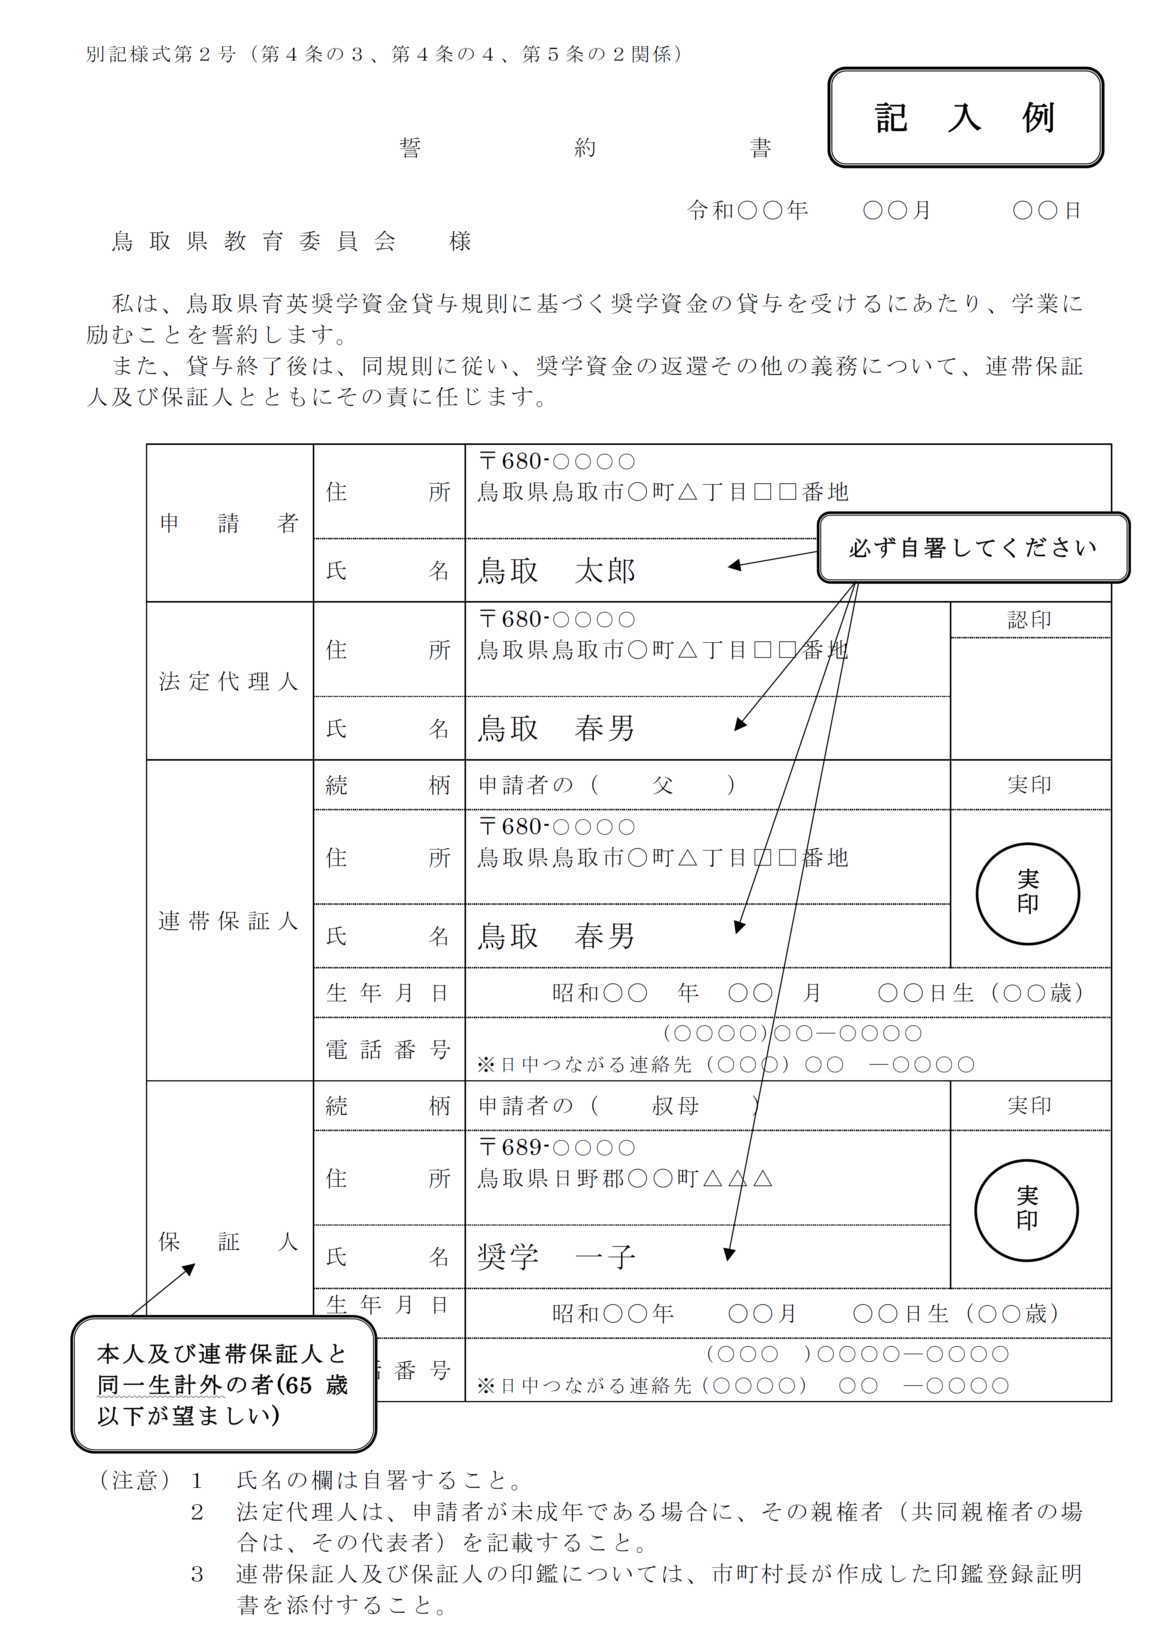

|  |  |  |  |  |  |  |
| --- | --- | --- | --- | --- | --- | --- |
| よい例 | 失敗例 | | | | | |
|  | 二重 | 重ね | かすれ・不鮮明 | 欠け | にじみ | ごみづまり |